**Adding Items to the scene**

Go to the ‘Prefabs’ folder, find the item you want to add in the scene and just drag it in the scene.

In case you want to create a new Item, it is a bit difficult so I would suggest only do it if you know what you’re doing. But in any case, I will still tell you how to so you have an option.

If you don’t want to add anything, click HERE to skip this boring tutorial.

1. Add a QUAD. Right click in hierarchy and select QUAD in the 3D objects section.

2.Rename it anything, and MAKE SURE it has the ‘Item’ tag. You can change that under the name of the object.

3. Turn on ‘Convex’. Just makes it so you can select pickup the item from both sides.

4. Add ‘Interactable’ script I wrote to the Item. In the bottom of the inspector, click on the ‘Add Component’ button and search for ‘Interactable’. Click it to add it.

5. This is the tricky bit. It will ask for a name and a sprite. Type the type of item from the dictionary here. For example, if this is going to be a **PLANT** then type ‘Plant’. It must be exactly how it is in the dictionary.

If it’s a new item and is not added to the dictionary, make sure to add it in the dictionary as well.

The Sprite will be the image you want to show in the inventory when the item is picked up in game. To select it, click on the small dot and scroll through. Find the image and select it.

I will make it a plant for this example. It will look like this.

6. Now the visual part. A QUAD is a 2D square image. To change that, find the sprite you want to replace it with, find it in the ‘Sprites’ folder, and just drag any one image on the quad itself.

It will look like this.

7. to remove the background of the plant, select the material. Click here to directly open the material.

It will send you to the material. Just select the material and you’ll see this.

To remove the background and get the effect make sure you set the material properties EXACTLY as follows.

8. That’s it. It was that easy. 😂

**Shortcuts**

Press W to move selected objects

Press E to rotate selected objects

Press R to resize selected objects

Press CTRL + D to duplicate selected objects

Press DEL to delete selected objects

Hold SHIFT and click on multiple objects to select multiple objects

**About Data Storage**The data is stored in a dictionary.

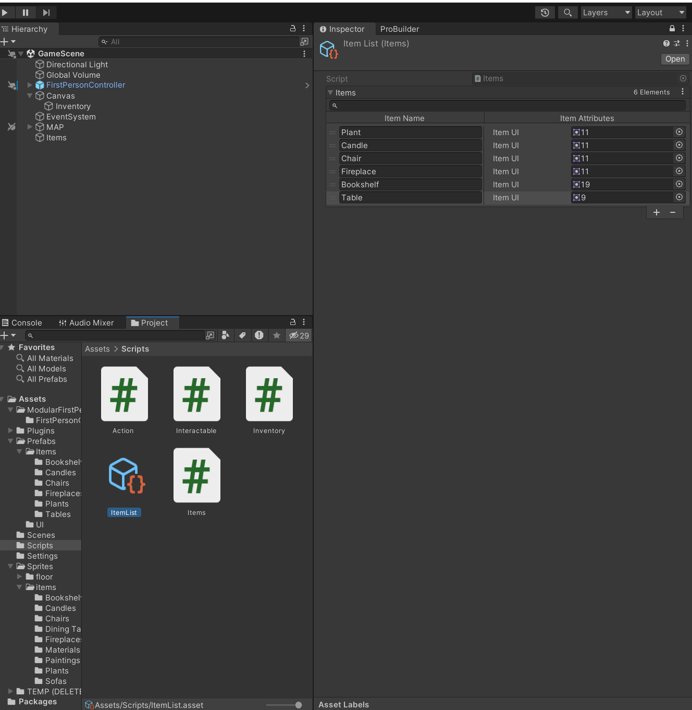

The way it works is, the string in the left columns are the keys, and the right column is the values column. Now, I’m only using keys because there’s not many values to store (The values showed in the screenshot are temporary and will be removed changed later).

**Others**

You can see a blue line in front of the player in the scene (only visible in Play mode). That blue line is the range of the player. It can be modified by changing the ‘Range’ value. Click on the player in Hierarchy, scroll to the bottom of the inspector, You’ll see the range.

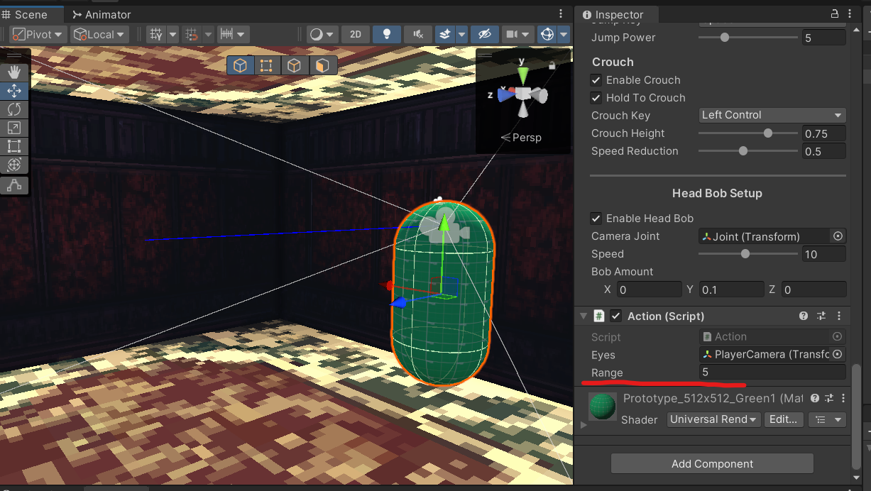

**Update Log**

I’ve cleaned some code and updated some stuff in the project. Doing so removed all the items placed in the scene. Sorry about that.